We invite you to attend a lecture by Pro Vice Chancellor of Social Cohesion, Professor and JL Dube Chair in Rural Education in the
School of Education at the University of KwaZulu-Natal, South Africa,
Dr. Relebohile Moletsane

Tuesday March 10th, 2020 @ 1pm in the Sociology Commons Room (first floor)

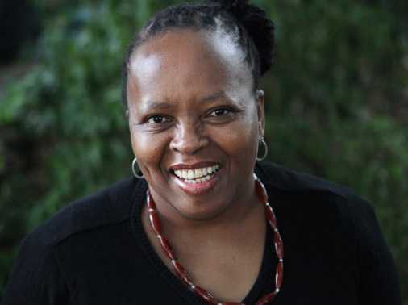

Nurturing Resilience Among Young People in the context of Sexual Violence

In many communities, unequal gender regimes and practices that make up the social ecologies in which girls and young women negotiate their lives tend to make vulnerable to gender-based violence, including sexual violence. Such social ecologies are often characterised by customary practices, including taboos relating to discussing sex and sexuality across generations. This silences dialogue and debate that could socialise young boys to respect women’s bodies and ultimately prevent the perpetration of violence in families and communities. Girls and women are left to negotiate their lives in the context of this violence without the necessary normative social intervention.
This presentation will explore the ways in which challenging and ultimately transforming the unequally gendered social ecologies (in families, communities, institutions, the workplace and the streets) that make it possible for sexual violence to occur, might help build resilience among girls and young women. The presentation will explore how girls in rural communities might effectively negotiate their lives and overcome the negative impacts of violence, including sexual violence. In particular, using an ecological systems approach, it will explore resilience as a co-produced process of positive adjustment (Panter-Brick, 2015; Ungar, 2015) among girls and between girls and significant others in communities. Findings from ongoing research with girls and young women in rural KwaZulu-Natal (see Moletsane, 2018) suggest that creating spaces for critical dialogue, debate and action (through for example, the use of participatory visual methods), enables girls and young women to not only deepen their understandings of sexual violence, it also helps them to identify possible strategies for addressing it. PVM allows the girls and young women, through their agentic engagement with their peers, adults in schools and communities, and policy makers, to explore critical areas for intervention and strategies for promoting social change. Yet, some ethical dilemmas emerge from work that involves girls in speaking out and back to gendered violence in communities and institutions. For example, does their resilience and involvement in speaking back to such violence expose them to further danger of marginalisation or even violence? How might participatory researchers balance the need to ‘do least harm and most good’ and to “avoid any possible harmful consequences resulting from [participants’] identification” (Amnesty International, 2008, p.5), with the principles of participatory research that seek to nurture resilience among survivors of sexual violence?

References
Amnesty International (2008). ‘I am at the lowest end of all’: Rural women living with HIV face human rights abuses in South Africa. London: Amnesty International Publications.
Moletsane, R. (2018). “Stop the War on Women’s Bodies”: Facilitating a Girl-Led March Against Sexual Violence in a Rural Community in South Africa. Studies in Social Justice, 12 (2), 235-250.
Panter-Brick, C. (2015). Culture and resilience: Next steps for theory and practice. In L. C. Theron., L. Liebenberg &M.Ungar (Eds.), Youth resilience and culture: Commonalities and complexities (pp. 233-244). Dordrecht, NL: Springer.
Ungar, M. (2015). Practitioner review: Diagnosing childhood resilience – a systemic approach to the diagnosis of adaptation in adverse social and physical ecologies. Journal of Child Psychology and Psychiatry,56(1), 4-17. doi: 10.1111/jcpp.12306

Brief Biography:
Prof Relebohile Moletsane

Relebohile Moletsane (PhD) is Pro Vice Chancellor (Social Cohesion) and a Full Professor and the JL Dube Chair in Rural Education in the School of Education at the University of KwaZulu-Natal, South Africa. As part of her Chair in rural education, she has worked in South African rural schools and communities, focusing on Gender and Feminist Studies in Education, particularly teacher development around such issues as poverty alleviation, HIV & AIDS, gender inequality and gender-based violence as barriers to education and development for girls. Moletsane’s current work focuses on working with girls and young women to address sexual violence in rural communities. As part of this, she is co-PI with Claudia Mitchell, of an IPaSS grant: Networks for change and well-being: Girl-led ‘from the ground up’ approaches to addressing sexual violence in Canada and South Africa. Informed by the work of Claudia Mitchell in South Africa and other sub-Saharan countries, the project uses participatory visual methods to engage girls and young women in understanding sexual violence and developing strategies for addressing it. As recognition for her work on addressing poverty in rural communities, Moletsane was the 2012 winner of the Distinguished Women in Science (Humanities) Award presented by the National Department of Science and Technology. She was a 2014 Echidna Global Scholar at Brookings Institutions’ Centre for Universal Education, where she completed a research report: The Need for Quality Sexual and Reproductive Health Education to Address Barriers to Girls’ Educational Outcomes in South Africa. Washington, DC: Centre for Universal Education, The Brookings Institution.

Co-Sponsored by Department of Sociology, Feminist Research Institute, ADVANCE-UNM, and the Division of Equity and Inclusion.

