Need a Sociology or Criminology Advisement Appointment sooner?

First Week of Classes, January 16th – 19th : In-Person Drop-Ins for General Questions and Registration Issues: All Majors
Tuesday, 1/16/24: 2:00-4:00 PM
Wednesday, 1/17/24: 9:00-11:00 AM; 2:00-4:00 PM
Thursday, 1/18/24: 9:00-11:00 AM; 2:00-4:00 PM

Weekly Semester Drop-In Advisement: Sociology & Criminology Majors/Minors
In-person: Thursdays 9am-11am
Virtual Weeks:
February 19th – 23rd
March 18th – 22nd

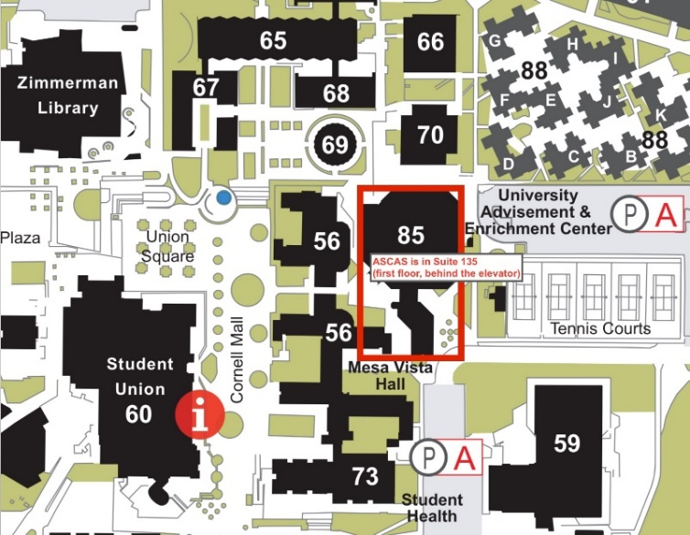
In Person Drop-in hours will be held at the Arts and Sciences Center for Academic Success:
- Located in the University Advisement and Enrichment Center (UAEC – Building 85) Suite 135 (ground floor, behind the elevator)
- You must check-in with the front desk assistant at ASCAS
For assistance, please call 505-277-4621

*Drop-In Appointments are 15-minute sessions for general questions and registration issues.
*These drop-ins are not meant to replace a full advising session but can help you with quick questions and concerns.
*Students on academic contracts for probation/suspension, need to change their major, degree plan, or require financial aid forms completed should schedule a 30-minute advisement meeting.

